

PROMOTION OF ACCESS TO INFORMATION MANUAL
2022

CONTENTS

no CLAUSE HEADINGS PAGE

1. INTRODUCTION 3
2. FUNCTIONS OF THE KZN DEPARTMENT OF COMMUNITY SAFETY AND LIAISON 5
3. STRUCTURE OF THE KZN DEPARTMENT OF COMMUNITY SAFETY AND LIAISON 8
a) Provincial Secretariat for Police 9
b) Corporate Management 12
4. KEY STAKEHOLDERS OF THE DEPARTMENT AND SERVICE BENEFITS 16
5. CONTACT DETAILS OF INFORMATION OFFICER 17
6. RECORDS 18
a) Categories of records 18
b) Records automatically available 19
7. CATERGORIES OF PERSONAL INFORMATION 20
8. REQUEST PROCEDURE 21
a) Request for access to a record 21
b) Transfer of a Request for Access to a record 22
c) Procedure where record cannot be found 22
d) Deferral of Access to a record 22
e) Time Frames and Notice to a Requestor 22
f) Denial of access to a record 23
g) Extension of period to decide on Request 23
h) Mandatory refusal to a request for access to a record 23
i) Discretionary refusal of a Request for Access 24
j) Other grounds for refusal to a Request for Access to a record 25
k) Fees payable for a request and notification of decision on access 25
l) Remedies available in respect of acts or failures to act 25
9. DISPOSAL OF RECORDS 26
10. PUBLIC INVOLVEMENT IN THE FORMULATION OF POLICY AND THE EXERCISE OF POWERS OR PERFORMANCE OF DUTIES 27
11. FEES PAYABLE IN TERMS OF THE INFORMATION ACT 27
12. APPROVAL BY INFORMATION OFFICER 29
ANNEXURE A 30
ANNEXURE B 36
ANNEXURE C 42

INTRODUCTION

Section 32(1)(a) of the Constitution of the Republic of South Africa Act of 1996 provides that everyone has the right of access to –
  - any information held by the state; and
  - any information that is held by another person that is required for the exercise or protection of any rights.

Section 32(2) of the Constitution provides for the enactment of national legislation to give effect to this right.

The Promotion of Access to Information Act, 2000 (Act 2 of 2000)(PAIA), gives all South Africans the right to have access to records held by the state, government institutions and private bodies.

Every public and private body is required to compile a manual in at least three official languages. In addition, members of the public may access the Guidelines on how to use the PAIA, at https://inforegulator.org.za/paia-guidelines/.

Furthermore, Section 14 of the Constitution provides that everyone has the right to privacy, and the right to privacy includes a right to protection against the unlawful collection, retention, dissemination and use of personal information.

The Protection of Personal Information Act, 2013 (Act 4 of 2013)(POPIA), was enacted to promote the protection of personal information processed by public and private bodies. It also prescribes the minimum requirements (8 conditions for lawful processing of personal information) for the processing of personal information.

The Department of Community Safety and Liaison of KwaZulu-Natal has compiled this manual in order to assist a requestor who wishes to obtain information from this department and to detail –
- The purpose of processing personal information;
- a description of the categories of data subjects and of the information or categories of information relating thereto;
- the recipients or categories of recipients to whom the personal information may be supplied;
- any plans for trans-border flows of personal information; and
- a general description allowing preliminary assessment of the suitability of information security measures to be implemented and monitored by the Department.

Copies of the manual are available at the offices of the Department of Community Safety and Liaison and on its website (www.kzncomsafety.gov.za).

FUNCTIONS OF THE KZN DEPARTMENT OF COMMUNITY SAFETY AND LIAISON
The functions of the department are derived from section 206(1), 206(3) and 206(5) of the Constitution of the Republic of South Africa of 1996, the Civilian Secretariat for Police Service Act, 2011 (Act No. 2 of 2011), and the South African Police Service Act, 1995 (Act No. 68 of 1995). They are the following:

 | THE CONSTITUTION | SECTION
 | Determine the policing needs and priorities of the province | Section 206(1)
 | Monitor police conduct | Section 206(3)(a)
 | Oversee the effectiveness and efficiency of the police service, including receiving reports on the police service | Section 206(3)(b)
 | Promote good relations between the police and the community | Section 206(3)(c)
 | Assess the effectiveness of visible policing | Section 206(3)(d)
 | Liaise with the Cabinet member responsible for policing with respect to crime and policing in the province | Section 206(3)(e)
 | Investigate, or appoint a commission of inquiry into, any complaints of police inefficiency or a breakdown in relations between the police and any community | Section 206(5)(a)
 | Make recommendations to the Cabinet member responsible for policing | Section 206(5)(b)
 | CIVILIAN SECRETARIAT FOR POICE SERVICE ACT, 2011 | SECTION
 | Provincial secretariats must assist the Civilian Secretariat (national) to achieve its objects, and perform functions and exercise powers of the Civilian Secretariat in the provincial sphere of government in accordance with the principles of co-operative government and intergovernmental relations contained in Chapter 3 of the Constitution. | Section 4(5)
 | Monitor the performance of the police service and regularly assess the extent to which the police service has adequate policies and effective systems and to recommend corrective measures | Section 6(1)(a)
 | Monitor the utilisation of the budget of the police service to ensure compliance with any policy directives or instructions of the Minister | Section 6(1)(b)
 | Monitor and evaluate compliance with the Domestic Violence Act, 1998 (Act 116 of 1998), and make recommendations to the police service on disciplinary procedures and measures with regard to non-compliance | Section 6(1)(c) & (d)
 | Consider such recommendations, suggestions and requests concerning police and policing matters as it may receive from any source | Section 6(1)(e)
 | Conduct or cause to be conducted any research as it may deem necessary | Section 6(1)(f)
 | Enter into either memoranda of understanding or agreements or both, in consultation with the Minister, with civilian oversight groups and other parties and engage such groups and parties to strengthen co-operation between the various role-players | Section 6(1)(g)
 | Assess and monitor the police service's ability to receive and deal with complaints against its members | Section 6(1)(j)
 | In order to support the objects of the Civilian Secretariat referred to in section 5 and subject to the principles of co-operative governance and intergovernmental relations contained in Chapter 3 of the Constitution, each provincial secretariat must-  - align its plans and operations at the provincial sphere of government with the plans, policies and operations of the Civilian Secretariat; and  - integrate its strategies and systems at the provincial sphere of government with the strategies and systems of the Civilian Secretariat. | Section 17(1)
 | The provincial secretariat must establish competencies and capabilities in its operations, to-  - monitor and evaluate the implementation of policing policy in the province;  - evaluate and monitor police conduct in the province;  - develop and evaluate safety models and monitoring tools to ensure alignment with the functions of the Civilian Secretariat;  - assist the Civilian Secretariat with any monitoring and evaluation projects; and  - promote community police relations;  - establish and promote partnerships; and  - manage the enhancement of community safety structures with the province. | Section 17(2)
 | The head of a provincial secretariat in each province must, through the head of a provincial department, submit to the MEC and the Secretary quarterly reports on the activities of a provincial secretariat in the province, and on any matter as or when required by the Secretary. | Section 22(1)
 | The head of a provincial department must submit regular reports to the MEC and the relevant committee in the provincial legislature. | Section 22(2)
 | The head of a provincial department in each province must-  - through the MEC, table an annual report in the provincial legislature on the activities of a provincial secretariat in the province; and  - submit a copy of the annual report tabled in terms of paragraph (a) to the Secretary. | Section 22(3)
 | The Secretary and heads of provincial departments must meet at least on a quarterly basis | Section 23(1)
 | The Civilian Secretariat must monitor the implementation by the police service of the recommendations made by the Independent Police Investigative Directorate and provide the Minister with regular reports on steps taken by it to ensure compliance, and a copy thereof must be sent to the Executive Director. | Section 31(2)
 | SOUTH AFRICAN POLICE SERVICE ACT, 1995
 | Provide direction on the establishment of Community Police Forums and Boards | Section 19 to 21
 | Ensure that the conditions subject to which a municipal police service was established are complied with and that national standards are maintained | Section 64N

In addition to these functions, the Public Finance Management Act of 1999, the Labour Relations Act of 1995 and the Public Service Act of 1994 requires the department to perform the following functions:
    - Financial Management;
    - Supply Chain Management;
    - Internal Control and Risk Management;
    - Legal Services;
    - Labour Relations;
    - Human Resource Administration and Development;
    - Information Technology Management; and
    - Physical Resource Management.

STRUCTURE OF THE KZN DEPARTMENT OF COMMUNITY SAFETY AND LIAISON
The Department is structured to fulfill its mandate outlined above. There are two main divisions within the department: Provincial Secretariat for Police and Corporate Management.
Figure 1 – Top structure

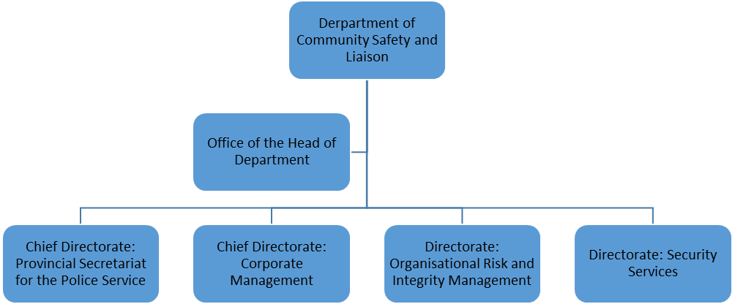

Provincial Secretariat for Police

The Provincial Secretariat is a chief directorate responsible for the following functions –
- monitors and evaluate the implementation of policing policies and directives;
- monitors and evaluate all police service units in the province;
- addresses complaints against police service delivery;
- reviews police practices, methodologies and performance;
- conducts research into the policing needs of the province;
- develops community safety models, initiatives and monitoring tools;
- develops and maintains community safety structures; and
- develops community safety partnerships.

The Provincial Secretariat is structured at a provincial and district level. The department has a Provincial Office situated in Pietermaritzburg. At a provincial level there are two directorates in the Provincial Secretariat. The first directorate performs the function of oversight over the Office of the Provincial Commissioner and Specialised Units as well as community police relations at a provincial level. The second is responsible for safety information analysis and conceptualisation. It continuously collates information from all the service units in the department and uses this information to review policing policies and directives, develop, evaluate and review community safety models, initiatives and monitoring tools, review police practices, methodologies and performance and conduct research into the policing needs of the province as required by the Constitution and the Act.

At a district level there are 10 district offices in the 10 District Municipalities and 3 offices in the Ethekwini Metro. The structure further distributes the 13 offices under five senior managers.
Figure 2 – Provincial Secretariat for Police
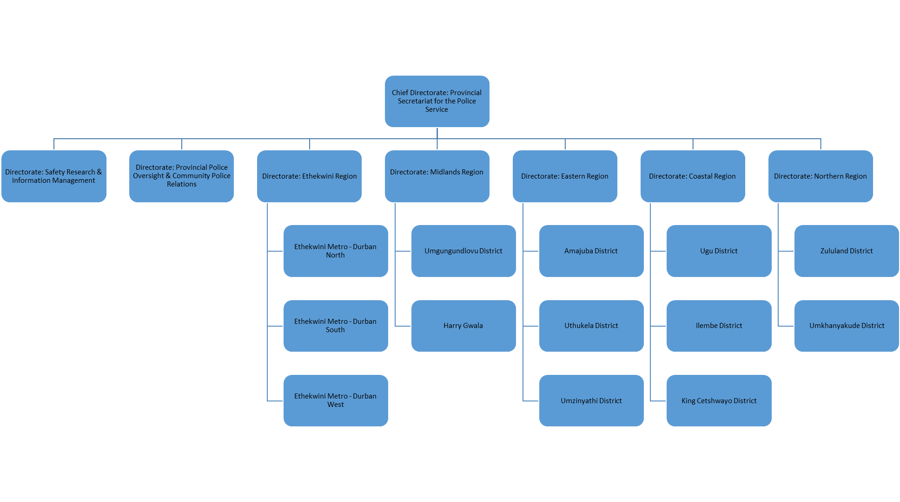
The district office performs the following functions:
- monitors and evaluates the implementation of policing policies and directives by police stations in the district;
- monitors and evaluates the service delivery of police stations in the district;
- addresses complaints against police stations in the district.
- develops and maintain Community Police Forums (CPFs), Community Safety Forums (CSFs), community crime prevention associations (CCPAs) and other safety structures in the district and harmonize their activities;
- implements community safety models and initiatives in the district;
- develops and maintains partnerships at district level.

Figure 3 – District Office Structure

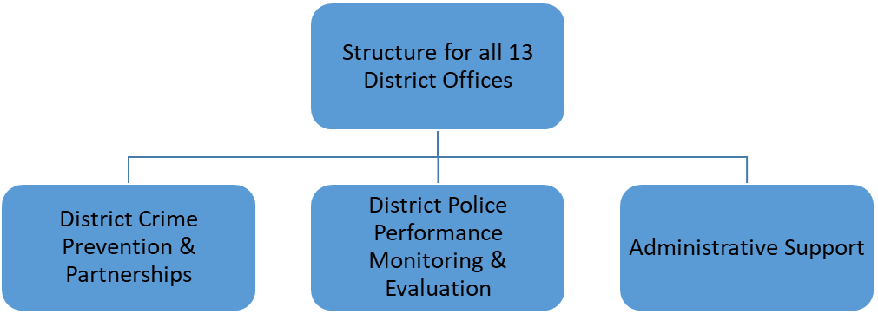

Corporate Management

The chief directorate provides support to the department. It consists of –
    - Corporate Services is responsible for HR Management, HR Administration, HR Development, Labour Relations, Safety, Health, Environment, Risk Quality (SHERQ) Employee Health and Wellness, Internal and External Communication, Information Technology and Auxiliary Services;
    - Legal Administrative Support provides legal services to the department;
    - Security Services is in charge of all security related matters;
    - Financial Management Services administers the finances of the department;
    - Intergovernmental Relations and Special Projects takes charge of IGR and programmes falling outside of the department’s service delivery programmes;
    - Strategic Planning and Internal Monitoring and Evaluation is responsible of planning and M&E of the performance of the department.

Figure 4 – Corporate Management
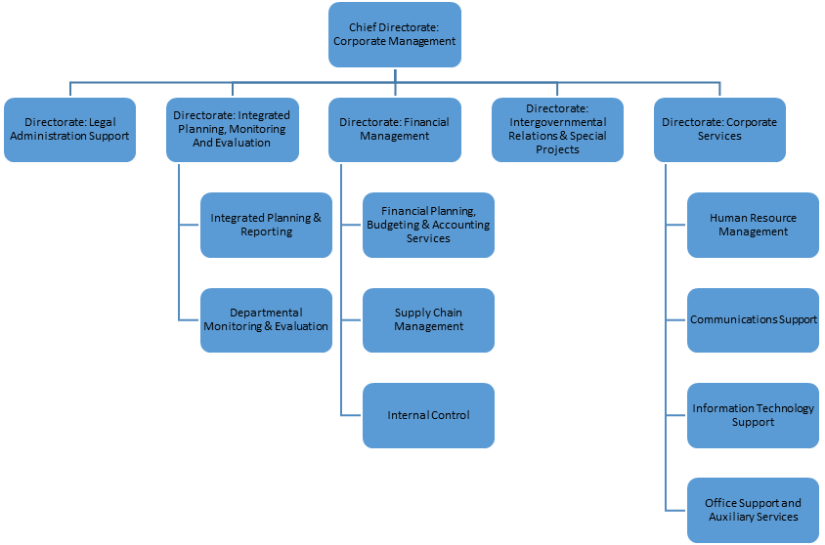
- Accessing Services of the Department at Provincial and Distrit Offices
The services of the Department may be accessed at the following addresses:

Provincial Office  Private Bag X9143, Pietermaritzburg, 3200  179 Jabu Ndlovu Street, Pietermaritzburg  Tel: +27 33 341 9300; Fax: +27 33 341 9403  Office Manager of the Head of Department  Contact: Silindile Bhengu (Mrs)  E-mail: silindile.dladla@comsafety.gov.za  Website: www.kzncomsafety.gov.za | eThekwini North District Office  Private Bag X54316, Durban, 4000  13th Floor, John Ross House, 20 Margaret Mncadi Avenue, Durban, 4000  Regional Director:  Mrs KE Mbongwe - 082 554 2469  E-mail: khaladi.mbongwe@comsafety.gov.za  District Coordinator:  Mr HN Mbhele - 082 300 5381  E-mail: holson.mbhele@comsafety.gov.za
eThekwini West District Office  Private Bag X9028, Pinetown, 3600  96 Crompton Street, Pinetown, Durban  Tel: 031-7374950  Regional Director:  Mrs KE Mbongwe - 082 554 2469  E-mail: khaladi.mbongwe@comsafety.gov.za  District Coordinator:  Ms F Buthelezi - 0824106835  E-mail: fikile.buthelezi@comsafety.gov.za | eThekwini South District Office  10th Floor, Truro House,  17 Margaret Mncadi Avenue, Durban  Tel: 031-5352553  Regional Director:  Mrs KE Mbongwe - 082 554 2469  E-mail: khaladi.mbongwe@comsafety.gov.za  District Coordinator:  Ms KB Mthembu - 082 300 5408  E-mail: khanyisile.mthembu@comsafety.gov.za
Ilembe District Office  Private Bag X10616, Stanger, 4450  2nd Floor, Albert Building, Cnr Link Road and R102, KwaDukuza  Tel: 032-4374200; Fax: 032-5581261  Regional Director:  Ms SN Chamane – 0834156757  E-mail: sandra.chamane@comsafety.gov.za  District Coordinator:  Mr JH Makhathini – 0825542463  E-mail: jabulani.makhathini@comsafety.gov.za | Ugu District Office  Private Bag X905, Port Shepstone, 4240  46 Bisset Street, Port Shepstone  Tel: 039-6881460; Fax: 039-6820759  Regional Director:  Ms SN Chamane – 0834156757  E-mail : sandra.chamane@comsafety.gov.za  District Coordinator:  Ms P Nkonyeni - 0605201253  E-mail: pretty.nkonyeni@comsafety.gov.za
Kind Cetshwayo District Office  25 Bredelia Street, KwaMbonambi, 3915  Regional Director:  Ms SN Chamane – 0834156757  E-mail : sandra.chamane@comsafety.gov.za  District Coordinator:  Mr M Nxumalo – 0827767539  E-mail: mdumeseni.nxumalo@comsafety.gov.za | Zululand District Office  Private Bag 32, Ulundi, 3838  LA Complex, King Dinuzulu Street, Ulundi  Tel: 035-8708600  Regional Director:  Mr I Nxumalo - 0823316856  E-mail: ismail.nxumalo@comsafety.gov.za  District Coordinator:  Mr AK Mtshali - 0825542465  E-mail: kwenza.mtshali@comsafety.gov.za
Umkhanyakude District Office  Private Bag X015, Mtubatuba, 3995  ERF 64, Dikkop Road, Umkuze, 3965  Tel: 035-5731628  Regional Director:  Mr I Nxumalo - 082 331 6856  E-mail: ismail.nxumalo@comsafety.gov.za  District Coordinator:  Mr KB Makhanya – 060 520 1367  E-mail: khonzani.makhanya@comsafety.gov.za | uMzinyathi District Office  Private Bag X2014, Dundee, 3000  65 Victoria Street, Dundee  Tel: 034-2997100; Fax: 034-2997116  Regional Director:  Dr LM Zondi - 082 776 7495  E-mail: lm.zondi@comsafety.gov.za  District Coordinator:  Ms SL Mkhwanazi - 082 4575462  E-mail: sissy.mkhwanazi@comsafety.gov.za
Amajuba District Office  Private Bag X5001, Madadeni, 2951  10431 Inkosi Bhambatha Street, Madadeni  Tel: 034-3296903  Regional Director:  Dr LM Zondi - 082 776 7495  E-mail: lawrence.zondi@comsafety.gov.za  District Coordinator:  Adv SC Ngceza – 0605201230  E-mail: sicelo.ngceza@comsafety.gov.za | uThukela District Office  Private Bag X7001, Estcourt, 3310  120 Alexander street, Estcourt  Tel: 036 3429040; Fax: 036-3429048  Regional Director:  Dr LM Zondi - 082 776 7495  E-mail: lawrence.zondi@comsafety.gov.za  District Coordinator:  Ms TM Ndlovu - 082 300 5384  E-mail: tshengisile.ndlovu@comsafety.gov.za
Umgungundlovu District Office  Temporary address: 179 Jabu Ndlovu Street, Pietermaritzburg  Tel: 033-3419300; Fax: 033-3419400  Regional Director:  Mr SS Kunene - 082 776 7598  E-mail: sabelo.kunene@comsafety.gov.za  District Coordinator:  Ms D Sibande - 082 300 5394  E-mail: dorah.ngubane@comsafety.gov.za | Harry Gwala District Office  Private Bag X558, Ixopo, 3276  38 Margaret Street, Ixopo  Tel: 039-8340054  Regional Director:  Mr SS Kunene - 082 776 7598  E-mail: sabelo.kunene@comsafety.gov.za  District Coordinator:  Ms N Malima-Tindleni – 060 520 1250  E-mail: ncebakazi.tindleni@comsafety.gov.za

KEY STAKEHOLDERS OF THE DEPARTMENT AND SERVICE BENEFITS

- Communities in the Province of KwaZulu-Natal
- Improved relations with the police.
- Enhanced community safety through efficient and effective policing by transformed police service.
- Government support to community structures that promote cooperation between the community and police.
- Safety structures to promote crime prevention.
- Crime prevention programmes.

- Community Policing Forums, Community Crime Prevention Associations and other safety structures
- Improved access to police.
- Organizational development.
- Improved capacity to meet objectives.

- Traditional Leaders
- Government support for the role of Traditional Leaders in responding to crime.
- Improved relations with the police.
- Enhanced community safety through efficient and effective policing.
- Safety structures to promote crime prevention.
- Crime prevention programmes.

- The South African Police Service
- Motivated and empowered police service.
- Adequate human, financial and logistical support to the provincial police.
- Improved relations with and cooperation from the community.
- A transformed police service in KwaZulu-Natal.

- Minister of Police
- Provincial police compliant with national policies, norms and standards.
- Improved coordination with respect to fighting crime and effective policing in the province.
- National policy informed by provincial needs.

- Other Justice, Crime Prevention and Security Cluster Departments
- Improved coordination in respect of the criminal justice system.
- Improved detective services.
- Integrated law enforcement initiatives.

- Provincial Legislature
- Effective oversight of department activities on behalf of citizens.
- Efficient and economical utilization of public resources.

- Other provinces
- Cross-border crime prevention.
- Improved intergovernmental relations.
- Integrated law enforcement initiatives.

- NGOs, FBOs, Business, Organised Labour, Political Parties, Private Security Industry, Transport Industry
- Improved access to police.
- Integrated crime prevention initiatives.
- Participation in safety structures.
- Conflict mediation and resolution services.
- Election monitoring.

CONTACT DETAILS OF INFORMATION OFFICER

The Acting Head of the Department of Community Safety and Liaison, Mr RL Goniwe, is the Information Officer in terms of the PAIA. The Department has one Deputy Information Officer, Adv C van Niekerk.

Information Officer: Mr RL Goniwe

Postal Address: Private Bag X9143, Pietermaritzburg, 3200
Physical Address: 179 Jabu Ndlovu Street, Pietermaritzburg, 3201
Tel: (033) 341 9326
Fax: (033) 341 9403
Cell: (082) 3317364
E-mail: luvuyo.goniwe@comsafety.gov.za

Deputy Information Officer: Adv C van Niekerk

Postal Address: Private Bag X9143, Pietermaritzburg, 3200
Physical Address: 179 Jabu Ndlovu Street, Pietermaritzburg, 3201

Tel: (033) 341 9300
Fax: (033) 341 9411
Cell: (082) 822 2150
E-mail: chris.vanniekerk@comsafety.gov.za

RECORDS

Categories of records

The Department holds the following categories of records:
- Financial management records;
- Asset management records;
- Supply chain management records;
- Human resources and personnel management records;
- Skills development and bursaries records;
- Plans, policies and guidelines to combat COVID-19;
- Personal Protection Equipment records;
- Fleet management records;
- Building management records;
- Contracts, legal opinions and litigation records;
- Policies, manuals, standard operating procedures and guidelines;
- Information technology management records;
- Communication and promotional material;
- Strategic planning and internal monitoring records;
- Internal management records;
- Stakeholder interaction records;
- Intergovernmental relations records;
- Project management records;
- Service delivery evaluations of the police service;
- Safety structures and activities;
- Research and development records;
- Complaints against police service reports.

The records listed under the paragraph below are automatically available. In respect of the remainder of the records, access must be requested in terms of the Act. Note must be taken that these include records classified as confidential, secret and top secret, access to which will only be granted subject to compliance with the Minimum Information Security Standards requirements (MISS).

Records automatically available

DESCRIPTION OF CATEGORY OF RECORDS AUTOMATICALLY AVAILABLE IN TERMS OF SECTION 15(1)(a) OF PAIA | MANNER OF ACCESS TO RECORDS
FOR INSPECTION IN TERMS OF SECTION 15(1)(a)(i):
DEPARTMENTAL STRATEGIC PLANS | The records on the website of the department, http://www.kzncomsafety.gov.za/ are available for viewing or downloading without a person having to make such a request in terms of the said Act.
DEPARTMENTAL ANNUAL PERFORMANCE PLAN
ANNUAL REPORTS
EMPLOYMENT EQUITY REPORTS
PUBLISHED RESEARCH REPORTS
APPROVED ORGANIZATIONAL STRUCTURES
BUDGETS
DEPARTMENTAL POLICIES AND PROCEDURE MANUALS
PROMOTION OF ACCESS TO INFORMATION MANUAL
SERVICE CHARTERS
STATEMENT OF COMMITMENT
DEPARTMENTAL EVENTS CALENDAR
COPIES OF SPEECHES BY THE MEC
CIRCULARS OF ADVERTISED POSTS AND SERVICES
DEPARTMENTAL FORMS
STAFF CONTACT DETAILS DIRECTORY
JOURNALS AND MAGAZINES
PROMOTIONAL MATERIAL
DEPARTMENTAL MEDIA STATEMENTS
FOR PURCHASING IN TERMS OF SECTION 15(1)(a)(ii):
TENDER DOCUMENTS | Records can be purchased at Financial & Accounting Services Office, No. 4 Ground Floor, Department of Community Safety & Liaison, Head Office, 179 Jabu Ndlovu Street, Pietermaritzburg, 3200
FOR COPYING IN TERMS OF SECTION 15(1)(a)(ii):
DEPARTMENTAL STRATEGIC PLANS | The records may be inspected at the Department on request, addressed to the Office of the Deputy Information Officer, Department of Community Safety & Liaison, Head Office, 179 Jabu Ndlovu Street, Pietermaritzburg, 3201; Private Bag X9143, Pietermaritzburg, 3200
DEPARTMENTAL ANNUAL PERFORMANCE PLAN
ANNUAL REPORTS
EMPLOYMENT EQUITY REPORTS
PUBLISHED RESEARCH REPORTS
APPROVED ORGANIZATIONAL STRUCTURES
BUDGETS
DEPARTMENTAL POLICIES AND PROCEDURE MANUALS
PROMOTION OF ACCESS TO INFORMATION MANUAL
SERVICE CHARTERS
STATEMENT OF COMMITMENT
DEPARTMENTAL EVENTS CALENDAR
COPIES OF SPEECHES BY THE MEC
CIRCULARS OF ADVERTISED POSTS AND SERVICES
DEPARTMENTAL FORMS
STAFF CONTACT DETAILS DIRECTORY
JOURNALS AND MAGAZINES
PROMOTIONAL MATERIAL
DEPARTMENTAL MEDIA STATEMENTS
AVAILABLE FREE OF CHARGE IN TERMS OF SECTION 15(1)(a)(iii):
STAFF CONTACT DETAILS DIRECTORY | The records may be requested from the Department, addressed to the Office of the Deputy Information Officer, Department of Community Safety & Liaison, Head Office, 179 Jabu Ndlovu Street, Pietermaritzburg, 3201; Private Bag X 9143, Pietermaritzburg, 3200
JOURNALS AND MAGAZINES
PROMOTIONAL MATERIAL
DEPARTMENTAL MEDIA STATEMENTS

CATERGORIES OF PERSONAL INFORMATION

The categories of personal information processed by the Department are contained in Annexure A, which specifies the Processing Component, Data Subjects, Personal Information Processed, Processing Purpose, Collection Origin, Processes, Record Formats, Disposal of Records and Authority for Processing.

The categories of recipients to whom the personal information may be supplied are the following:
1. employees of the Department;
2. the South African Police Service / Metro Police Service;
3. other relevant stakeholders in the Criminal Justice System;
4. the State Information Technology Agency;
5. the Auditor-General;
6. Provincial Archives; or
7. any other Organs of State for purposes of performing their public functions or their agents.

The Department does not plan any trans-border flows of personal information, but monitors same in order to ensure compliance with the Act. The security measures implemented and monitored by the Department include contractual arrangements with operators, offices safeguarded by private security on a 24/7 basis, record access protocols and appropriate technical security measures.

REQUEST PROCEDURE

Request for access to a record

If a requester wishes to make a request for access to a record of the KwaZulu-Natal Department of Community Safety and Liaison, he or she must make a written request to the Information Officer or the Deputy Information Officer whose contact details are listed under paragraph 5 hereof.

A requester wishing to make a request must use Form 2, which is included in this manual as Annexure B.

Requesters must provide sufficient information in Form 2 to enable the Information Officer to identify the record requested, including a description of the record, a reference number, if any, and any further particulars of the record. The requester must also include all his/her contact details and the language in which he/she wishes to obtain the record. If the record is not available in the language preferred by the requester, access may be given in the language in which it is available.

An oral request may be made if a requester is illiterate or unable to make a written request because of disability or/and other factors. The Information Officer or her deputy must assist the requestor by putting the request in a written form and giving a copy of the written request to the requester.

The Information Officer must assist a requester who requires assistance with making a request for a record. Assistance must be provided free of charge.

A requester must indicate the form in which access to a record is required, i.e. –
  - whether he wishes to make a copy of the record;
  - whether he needs the record to be in written or printed form or if he/she wishes to inspect the record;
  - if the record is a visual image, i.e. videos, photographs, slides, computer generated images, whether he/she wishes to access a copy of the images, have a transcript or to view them;
  - Whether the requestor wishes to access a printed copy of information derived from the record or copy computer readable form (e.g. memory stick).

Transfer of a Request for Access to a record

The Information Officer or his Deputy may transfer a request for access to a record where:
- the requested record is not under the direct control of the Department of Community Safety and Liaison; or
- the subject matter of the requested record is more closely connected to another public body.

Procedure where record cannot be found

If a record cannot be found, the Information Officer or Deputy Information Officer must, by way of affidavit or affirmation, notify the requester that it is not possible to give access to that particular record.

Deferral of Access to a record

Access may be deferred where the record is not yet available.

Time Frames and Notice to a Requestor

The Information Officer or the Deputy Information Officer must decide within 30 days whether to grant the request and then send a notice to the requestor.

Where access is granted, the notice from the Information/Deputy Information Officer must:
- state where and when the access fee, if any, must be paid;
- state the form in which access will be granted; and
- state how an appeal may be lodged with the department against the Access Fee or the form in which access is to be granted.

Denial of access to a record

Where access is denied, the notice from the Information/ Deputy Information Officer must:
- give adequate reasons;
- not make any mention or reference to the content of the record;
- state that the requestor may lodge an internal appeal with the department or make an application with a court against the denial of access;
- indicate the procedure for lodging an internal appeal.

Extension of period to decide on Request

The Information Officer/Deputy Information Officer may extend the period of 30 days once only, and for a further period of 30 days in which to decide on the request if –
- the requester consents in writing to the extension;
- the request is for a large amount of information that may take a considerable amount of time to research, and may affect the daily operations of the department; or
- consultation is necessary with other public bodies that might be affected by the record.

Mandatory refusal to a request for access to a record

Mandatory refusal to a request for access to a record must be applied by the Information Officer/Deputy Information Officer for the following reasons:
- protection of privacy;
- if the disclosure would involve the unreasonable or unlawful disclosure of personal information about a third party, including a deceased individual;
- protection of commercial information of a third party;
- protection of certain confidential information;
- protection of confidential information of a third party;
- protection of safety for individuals and protection of property;
- mandatory protection of police dockets in bail proceedings and protection of law enforcement and legal proceedings;
- protection of records privileged from production in legal proceedings;
- defense, security and internal relations of the Republic of South Africa;
- economic interest and financial welfare of the Republic and commercial activities of public bodies;
- protection of research information of a third party, and protection of research information of a public body;
- substantial and unreasonable diversion of the department’s resources when researching the requested information;
- protection of computer programs owned by a private body.

Discretionary refusal of a Request for Access

The Information Officer/Deputy Information Officer may refuse access to record where a request for access to information would involve disclosure of:-
- Information supplied in confidence by a third party.
- Information, the disclosure of which may impair the security of a structure or system.
- Information vital to in the protection of an individual in a Witness Protection scheme.
- Security of the public and property.
- Information on computer programs owned by the state or public body, defined in the Copyright Act No. 98 of 1978.
- Information about a record of a public body which contains an opinion, advice, report, recommendation or an account of a consultation, deliberation or minutes of a meeting on the formulation of a policy
- A record containing methods, techniques, guidelines used in the prevention, detection, investigation of a crime or prosecution of an offender which may result in the miscarriage of justice
- A record, if disclosed may prejudice an investigation into a crime, enable a person to identify a source, result in the intimidation of witnesses, facilitate in the commission of a contravention of the law, or prejudice the fairness of a trial
- Information, the disclosure of which could prejudice the defense, security or international relations of the Republic of South Africa
- Information, the disclosure of which is likely to materially jeopardize the economic or financial interest of the Republic of South Africa, or the government’s ability to manage the economy of the country effectively.
- Information which contains trade secrets of the state or a public body, the disclosure of which is likely to cause harm to the commercial or financial interests of the state or a public body.

Other grounds for refusal to a Request for Access to a record

The Information Officer or Deputy Information Officer may refuse a request for access to a record if the request is manifestly frivolous or the work involved in processing the request would substantially and unreasonably divert the resources of the Department of Community Safety and Liaison.

Fees payable for a request and notification of decision on access

- A requester who seeks access to a record containing personal information about him/her is not required to pay the request fee.
- Every other requester must pay the request fee of R100.00. Complete Form 2 and submit it to the Information Officer either at the department’s physical address, fax number or electronic mail address together with the request fee.
- The Information Officer must notify the requester (other than a personal requester) by notice, requiring the requester to pay the prescribed request fee (if any) and deposit (if any) before further processing the request.
- The requester may lodge an internal appeal, where appropriate, or an application to the court against the tender or payment of a fee. After the Information Officer has made a decision on the request the requester must be notified of such a decision in the way in which the requester wanted to be notified in.
- If the request is granted then a further access fee must be paid for the reproduction and for search and preparation for any time required in excess of stipulated hours to search and prepare the record for disclosure.
- Access to a record will be withheld until all the applicable fees have been paid.

Remedies available in respect of acts or failures to act
The following procedures exist for persons to report or remedy alleged irregular, improper or unlawful official acts or omissions by the department or any of its employees:
(i) Remedies in respect of acts or failures to act in terms of the PAIA: An internal appeal may be lodged using Form 4 (Annexure C). The internal appeal authority for purposes of the Act is the Member of the Executive Council responsible for the department. After exhausting the internal appeal remedy an application may be lodged with a court.
(ii) A public service employee may lodge a grievance or compliant for investigation by the Public Service Commission concerning an official act or omission (section 35 of the Public Service Act, 1994).
(iii) A person may use labour remedies regarding official acts or omissions of a labour nature, namely disputes of rights (the Public Service Act, 1994, and Labour Relations Act, 1995).
(iv) A person may lodge a complaint with a labour inspector concerning any alleged contravention of the Basic Conditions of Employment Act, 1997 (Act No. 75 of 1997 - section 78(1) (a)), or the Employment Equity Act, 1998 (Act No. 55 of 1998 - section 34(e)).
(v) A person may lodge a compliant with the Public Protector concerning a suspected unlawful or improper official act or omission (the Constitution and the Public Protector Act, 1994 (Act No. 23 of 1994)).
(vi) A person may lodge a complaint with the South African Human Rights Commission concerning an official act or omission that is suspected to constitute a violation of or threat to any fundamental right (Human Rights Commission Act, 1994 (Act No. 54 of 1994)).
(vii) In order to be protected from reprisals because of a disclosure regarding unlawful or irregular conduct by the employer or a fellow employee, the person in question may follow the disclosure procedures in the Protected Disclosures Act, 2000 (Act No. 26 of 2000).
(viii) A person may use other legal remedies such as the institution of proceedings for the judicial review of an administrative action in terms of the Promotion of Administrative Justice Act, 2000 (Act No. 3 of 2000).
(ix) A person may request reasons for an administrative action in terms of section 5 of the Promotion of Administrative Justice Act, 2000 (Act No. 3 of 2000).

DISPOSAL OF RECORDS
The Department reserves the right to lawfully dispose of certain records in terms of authorities obtained from the National Archives and Records Service.
Requesters will be advised whether a particular record has been disposed of where this is relevant to the records requested.
In accordance with section 24(1) of POPIA, the Department may, upon receipt of the request from a data subject –
- correct or delete personal information about the data subject in its possession or under its control that is inaccurate, irrelevant, excessive, out of date, incomplete, misleading or obtained unlawfully; or
- destroy or delete a record of personal information about the data subject that the Department is no longer authorised to retain in terms of section 14 of POPIA.

PUBLIC INVOLVEMENT IN THE FORMULATION OF POLICY AND THE EXERCISE OF POWERS OR PERFORMANCE OF DUTIES
In the exercise of its powers or performance of its duties in terms of PAIA and POPIA, the public are from time to time invited to attend engagement sessions, make representations or to participate in or influence the development of crime prevention / community policing processes, policies, guidelines or strategies.
Members of the public can, at any time, make representations to the department regarding the police oversight, crime prevention or community policing falling within the ambit of the departmental mandate.
The public are also encouraged to participate in public consultation and stakeholders’ engagement arranged by the department.
The platform utilised for public participation may either be through public meetings (physical or virtually), email or written submissions.
The inputs and submissions of members of the public are considered intensively during the formulation of any policies, guidelines or strategies. The department disseminates information to the public via electronic and print media, government gazette as well as social media.

FEES PAYABLE IN TERMS OF THE INFORMATION ACT
Item | Description | Amount
1 | The request fee payable by every requester | R100.00
2 | Photocopy of A4-size page | R1.50 per page or part thereof.
3 | Printed copy of A4-size page | R1.50 per page or part thereof.
4 | For a copy in a computer-readable form on:
 | (i) Flash drive (to be provided by requestor)  (ii) Compact disc | R40.00
 | • If provided by requestor | R40.00
 | • If provided to the requestor | R60.00
5 | For a transcription of visual images per A4-size page | Service to be outsourced. Will depend on quotation from Service provider.
6 | Copy of visual images
7 | Transcription of an audio record, per A4-size page | R24.00
8 | Copy of an audio record on:
 | (i) Flash drive (to be provided by requestor)  (ii) Compact disc | R40.00
 | • If provided by requestor | R40.00
 | • If provided to the requestor | R60.00
9 | To search for and prepare the record for disclosure for each hour or part of an hour, excluding the first hour, reasonably required for such search and preparation. | R100.00
 | To not exceed a total cost of | R300.00
10 | Deposit: If search exceeds 6 hours | One third of amount per request calculated in terms of items 2 to 8.
11 | Postage, e-mail or any other electronic transfer | Actual expense, if any.

APPROVAL BY INFORMATION OFFICER

Approved on this …….day of ……………………….. 2022

_______________________________
MR RL GONIWE
ACTING HEAD OF DEPARTMENT

ANNEXURE A

Processing Component | Data Subjects | Personal Information | Processing Purpose | Collection | Processes | Record formats | Disposal of records | Authority for Processing
Human  Resources | Applicants for employment | Names, IDs, addresses, contact details, race, gender, experience, qualifications, employment details | To process applications for employment | Direct | Receive, screening, verification, evaluate during recruitment process and filing | Physical files, electronic (hard drives, server) | Records Management Policy | S11(1)(d)  S29
Human  Resources | Employees and dependents | Names, IDs, PERSAL numbers, addresses, contact details, race, gender, experience, qualifications, employment details | To process career incidents | Direct & indirect | Appointment processes, PERSAL administration, leave administration, performance management, discipline management, medical aid and pension form processing, resignation / retirement processing | Physical files and electronic (hard drives, server, transversal system) | Records Management Policy | S11(1)(d)  S12(2)(c)  S32(f)(i)  Note: S30 only authorizes Trade Union to process information on union affiliation, not employers;
Fleet  Management | Employee drivers of vehicles and passengers | Names, contact details | To process access to State vehicles | Direct | Issuing of trip authorities, processing of application for subsidized vehicles | Physical files and electronic (hard drives, server) | Records Management Policy | S11(1)(d)
Information Technology | Employee users of system | Names, PERSAL number, e-mail addresses, passwords | To process access to IT system | Direct | Administration of access to system | Physical files and electronic (hard drives, server) | Records Management Policy | S11(1)(d)
Security  Services | Visitors | Names, IDs, contact details | To process access to offices | Direct | Registration of access | Physical files | Records Management Policy | S11(1)(a)
Security  Services | Employees | Names, IDs, PERSAL numbers, addresses, contact details, fingerprints | To process criminal records checks / vetting | Direct | Criminal record screening, security clearance processing | Physical files and electronic (hard drives, server) | Records Management Policy | S11(1)(d)
Asset Management | Employee users of assets | Names, PERSAL numbers | Process asset utilization and accountability | Direct | Recording of custodians of assets, reporting of losses | Physical files and electronic (hard drives, server, transversal system) | Records Management Policy | S11(1)(d)
Supply Chain Management | Bidders | Names, IDs, addresses, registration numbers, contact details | To process the evaluation and award of bids | Direct | Processing quotations or bids (screening, verification, evaluation and filing) | Physical files, electronic (hard drives, server) | Records Management Policy | S11(1)(d)
Supply Chain Management | Contracted service providers | Names, IDs, addresses, registration numbers, contact details, bank account details | Contract management | Direct | Processing contracts through to Legal Services and end-users | Physical files, electronic (hard drives, server) | Records Management Policy | S11(1)(b)
Accounting Services | Employees | Names, IDs, PERSAL numbers, bank account details | To process claims and payments | Direct | Payroll management; subsistence and transport claim administration | Physical files and electronic (hard drives, server, transversal system) | Records Management Policy | S11(1)(d)
Accounting Services | Service providers and creditors | Names, IDs, addresses, registration numbers, contact details, bank account details | To process claims, invoices and payments | Direct | Capturing banking details, processing payments | Physical files and electronic (hard drives, server, transversal system) | Records Management Policy | S11(1)(b)
Legal Services | Contracted service providers | Names, IDs, addresses, registration numbers, contact details, bank account details | To process the drafting and signing of contracts | Indirect | Receiving bids / quotations, drafting contracts | Physical files, electronic (hard drives, server) | Records Management Policy | S11(1)(b)  S12(2)(c)
Legal Services | Litigants and claimants | Names, IDs, addresses, registration numbers, contact details, bank account details | Administering court processes, claims, correspondence | Indirect | Filing claims, correspondence, transmitting documentation to attorneys | Physical files, electronic (hard drives, server) | Records Management Policy | S11(1)(d)  S12(2)(d)(iii)
Legal Services | Employees | Names, contact details | Assessing liability for losses | Direct | Filing requests and supporting docs, formulating opinions, transmitting same to CFO | Physical files, electronic (hard drives, server) | Records Management Policy | S11(1)(d)
Legal Services | Complainants | Names, IDs, addresses, registration numbers, CAS numbers, contact details | Providing legal opinions on cases | Direct / Indirect | Filing requests and supporting docs, formulating opinions, transmitting same to management | Physical files, electronic (hard drives, server) | Records Management Policy | S11(1)(c), (d) & (e)  S12(2)(c)
Provincial Secretariat  for Police | Complainants | Names, IDs, addresses, registration numbers, contact details | Investigation of complaints against police | Direct | Filing requests and supporting docs, transmitting same to SAPS, drafting reports to management, communicating with complainants | Physical files, electronic (hard drives, server) | Records Management Policy | S11(1)(c), (d) & (e)
Provincial Secretariat  for Police | Parties in conflict | Names, IDs, addresses, registration numbers, contact details | Facilitating mediation processes | Direct | Filing supporting docs, transmitting same to SAPS and other stakeholders, drafting reports to management, communicating with parties | Physical files, electronic (hard drives, server) | Records Management Policy | S11(1)(d)
Provincial Secretariat  for Police | Members of community safety structures | Names, IDs, addresses, registration numbers, contact details | Facilitating the functionality of safety structures | Direct | Recording information, communicating information to other members, stakeholders and SAPS, sending communication to data subject regarding activities | Physical files, electronic (hard drives, server) | Records Management Policy | S11(1)(c), (d) & (e)
Provincial Secretariat  for Police | Complainants / suspects / victims in criminal investigations | Names, IDs, addresses, registration numbers, contact details, CAS numbers | To assess the effectiveness of criminal investigations | Direct / Indirect | Filing requests and supporting docs, transmit same to SAPS / NPA, access dockets for review, drafting reports, transmitting same to management, communicating with complainants | Physical files, electronic (hard drives, server) | Records Management Policy | S11(1)(c), (d) & (e)  S12(2)(a) or (c)
Provincial Secretariat  for Police | Members of the public attending events / functions / workshops | Names, IDs, contact details | To facilitate participation in crime prevention programmes | Direct | Recording information in attendance registers, filing registers, making registers available for auditing | Physical files, electronic (hard drives, server) | Records Management Policy | S11(1)(c) / (e)
IGR and Special Projects | Volunteers | Names, IDs, PERSAL numbers, addresses, race, gender, bank account details | Processing applications, appointments, payments, discharge | Direct | Receiving / filing applications, conduct interviews, capture details on PERSAL and other systems, receiving / filing time-sheets, compile reports, submit details to DPW for EPWP administration | Physical files, electronic (hard drives, server) | Records Management Policy | S11(1)(d) / (e)

ANNEXURE B

Form 2
Request for access to record
[Regulation 7]

Note:
1 Proof of identity must be attached by the requester.
2 If requests made on behalf of another person, proof of such authorisation, must be attached to this form.

TO: | The information officer  __________________________  __________________________  __________________________  __________________________  (Address)
E-mail address:  Fax number: | __________________________  __________________________  __________________________
Mark with an 'X'

Request is made in my own name | Request is made on behalf of another person

PERSONAL INFORMATION

Full names:

Identity number:

Capacity in which request is made (when made on behalf of another person):

Postal Address:

Street Address:

E-mail Address:

Contact numbers: | Tel (B): |  | Facsimile:
 | Cellular:
Full names of person on whose behalf request is made (if applicable):

Identity number:

Postal Address:

Street Address:

E-mail Address:

Contact numbers: | Tel (B): |  | Facsimile
 | Cellular:
PARTICULARS OF RECORD REQUESTED
Provide full particulars of the record to which access is requested, including the reference number if that is known to you, to enable the record to be located. (If the provided space is inadequate, please continue on a separate page and attach it to this form. All additional pages must be signed.)

Description of record or relevant part of the record:

Reference number, if available:

Any further particulars

of record:

TYPE OF RECORD
(Mark the applicable box with an 'X')

Record is in written or printed form

Record comprises virtual images (this includes photographs, slides, video recordings, computer-generated images, sketches, etc)

Record consists of recorded words or information which can be reproduced in sound

Record is held on a computer or in an electronic, or machine-readable form

FORM OF ACCESS
(Mark the applicable box with an 'X')

Printed copy of record (including copies of any virtual images, transcriptions and information held on computer or in an electronic or machine-readable form)

Written or printed transcription of virtual images (this includes photographs, slides, video recordings, computer-generated images, sketches, etc)

Transcription of soundtrack (written or printed document)

Copy of record on flash drive (including virtual images and soundtracks)

Copy of record on compact disc drive (including virtual images and soundtracks)

Copy of record saved on cloud storage server

MANNER OF ACCESS
(Mark the applicable box with an 'X')

Personal inspection of record at registered address of public/private body (including listening to recorded words, information which can be reproduced in sound, or information held on computer or in an electronic or machine-readable form)

Postal services to postal address

Postal services to street address

Courier service to street address

Facsimile of information in written or printed format (including transcriptions)

E-mail of information (including soundtracks if possible)

Cloud share/file transfer

Preferred language:
(Note that if the record is not available in the language you prefer, access may be granted in
the language in which the record is available)

PARTICULARS OF RIGHT TO BE EXERCISED OR PROTECTED
If the provided space is inadequate, please continue on a separate page and attach it to this Form. The requester must sign all the additional pages.

Indicate which right is to be exercised or protected:

Explain why the record requested is required for the exercise or protection of the aforementioned right:

FEES

(a) A request fee must be paid before the request will be considered.
(b) You will be notified of the amount of the access fee to be paid.
(c) The fee payable for access to a record depends on the form in which access is required and the reasonable time required to search for and prepare a record.
(d) If you qualify for exemption of the payment of any fee, please state the reason for exemption.

Reason:

You will be notified in writing whether your request has been approved or denied and if approved the costs relating to your request, if any. Please indicate your preferred manner of correspondence:

Postal address | Facsimile | Electronic communication  (Please specify)

Signed at _______________ this __________ day of ________________________ 20 __________

_______________________________________________________
Signature of requester /person on whose behalf request is made

FOR OFFICIAL USE

Reference number:

Request received by: (state rank, name and surname of information officer)

Date received:

Access fees:

Deposit (if any):

______________________________________
Signature of information officer

ANNEXURE C
Form 4
Lodging of an internal appeal
[Regulation 9]

Reference number: _______________________

PARTICULARS OF PUBLIC BODY

Name of public body:

Name and surname of information officer:

PARTICULARS OF COMPLAINANT WHO LODGES THE INTERNAL APPEAL

Full names:

Identity number:

Postal address:

Contact numbers: | Tel (B): |  |  |  |  | Facsimile:
 | Cellular:
E-mail Address:

Is the internal appeal lodged on behalf of another person? | Yes |  |  |  |  |  | No
If answer is 'yes', capacity in which an internal appeal on behalf of another person is lodged: (Proof of the capacity in which appeal is lodged, if applicable, must be attached.)

PARTICULARS OF PERSON ON WHOSE BEHALF THE INTERNAL APPEAL IS LODGED (If lodged by a third party)

Full names:

Identity number:

Postal address:

Contact numbers: | Tel (B): |  |  |  |  | Facsimile:
 | Cellular:
E-mail address:

DECISION AGAINST WHICH THE INTERNAL APPEAL IS LODGED (mark the appropriate box with an 'X')

Refusal of request for access:

Decision regarding fees prescribed in terms of section 22 of the Act:

Decision regarding the extension of the period within which the request must be dealt with in terms of section 26(1) of the Act:

Decision in terms of section 29(3) of the Act to refuse access in the form requested by the requester:

Decision to grant request for access:

GROUNDS FOR APPEAL
(If the provided space is inadequate, please continue on a separate page and attach it to this form, all the additional pages must be signed.)

State the grounds on which the internal appeal is based:

State any other information that may be relevant in considering the appeal:

You will be notified in writing of the decision on your internal appeal. Please indicate your preferred manner of notification:

Postal address | Facsimile | Electronic communication (Please specify)

Signed at ________________ this ____________ day of _________________ 20 ____________

____________________________________
Signature of appellant/Third party

FOR OFFICIAL USE
OFFICIAL RECORD OF INTERNAL APPEAL

Appeal received by:
(state rank, name and surname of information officer)

Date received:

Appeal accompanied by the reasons for the information officer's decision and, where applicable, the particulars of any third party to whom or which the record relates, submitted by the information officer: |  |  |  |  | Yes
 |  |  |  |  | No
OUTCOME OF APPEAL

Refusal of request for access. Confirmed? | Yes |  |  | New decision  (if not confirmed)
 | No
Fees (Sec 22). Confirmed? | Yes |  |  | New decision  (if not confirmed)
 | No
Extension (Sec 26(1)). Confirmed? | Yes
 | No |  |  | New decision  (if not confirmed)

Access (Sec 29(3)). Confirmed? | Yes |  | New decision  (if not confirmed)
 | No
Request for access granted. Confirmed? | Yes
 | No |  | New decision  (if not confirmed)

Signed at ________________ this ____________ day of _________________ 20 ____________

__________________________
Relevant authority

